**SUCCESSFUL EXECUTION**

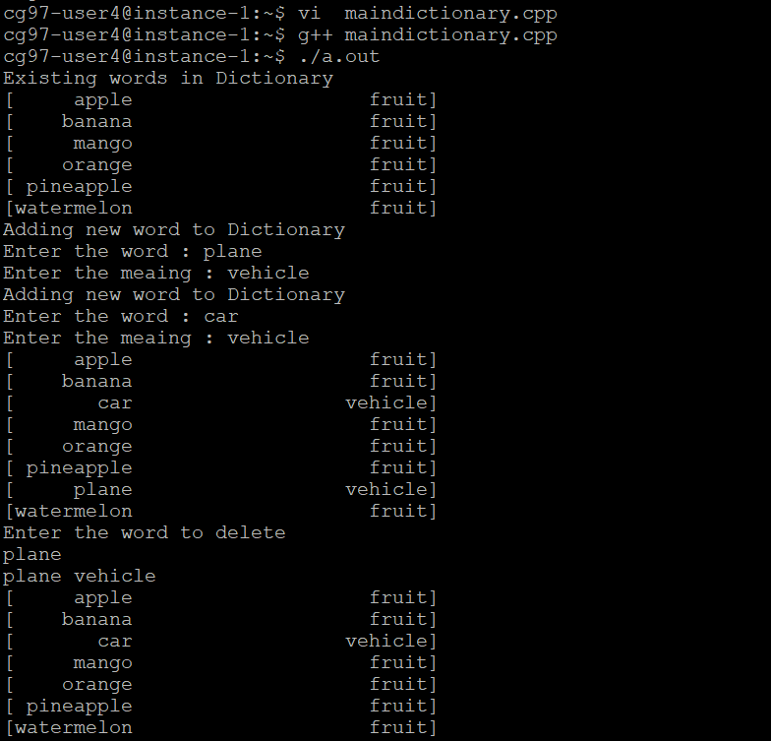

**UNSUCCESSFULL EXECUTION**

